GRADE: 4
ENGLISH FIRST ADDITIONAL LANGUAGE

TERM 2: EXEMPLAR TASK (Paper 2)
(RESPONSE TO TEXT & LANGUAGE)
MARKS: 40

DATE: _______________

LEARNER NAME: ______________________

This task consists of the following questions:
Question 1: Informational text (15)
Question 2: Visual text (10)
Question 3: Summary (5)
Question 4: Language structures & conventions (10)

Instructions to learners:
- Answer all the questions on the question paper.
- Use full sentences as far as possible
- Read through the texts before you answer the questions.

African Elephants
READ THE FOLLOWING INFORMATIONAL TEXT AND ASNWER THE QUESTIONS:
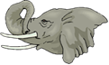

1  2  3  4  5  6  7 | African elephants are the largest mammals that live on land. They never stop growing.  Male African elephants can get to be 3,9 m tall if measured from the ground to the top of their shoulder. They can weigh up to 6350 kilograms.  African elephants have ears that are shaped like the continent of Africa. Elephants can flap their ears. The big ears help keep the elephants cool. Their bodies are hard and rough.  Elephants eat all day long. They feed on grass, small plants, bushes, fruit, vegetables, twigs, tree bark, and roots.  Elephants use their trunks to eat food and to squirt water into their mouths. They also breathe through their trunks.  Elephants have two tusks, which are made of ivory. The tusks grow to the right and the left sides of their trunks. Elephants can use their tusks to fight and to dig. Poachers kill elephants so that they can get their tusks.  Ivory was used to make beautiful jewelry and statues. It is against the law to hunt elephants now, because hunting them has made them endangered animals.

 | QUESTION 1
 | Answer all the following questions.
1.1. | Fill in the missing word.  ____________________________elephants are the largest mammals on land. |  |  | (1)
1.2. | How much does a male elephant weigh?  ____________________________________________________________________ |  |  | (1)
1.3. | Write down the letter of the correct answer.  Elephants use their ears to…  _____________ |  |  | (1)
 | A |  | cool off.
 | B |  | stay dry.
 | C |  | keep fit.
 | D |  | get healthy.
1.4. | Write down 2 things that an African elephant eats.  _________________________________________  _________________________________________ |  |  | (2)
1.5. | Describe how an elephant’s skin feels like.  _____________________________________________________________________ |  |  | (1)
1.6. | Complete the following sentence:  Elephants use their tusks to ___________ and to _______________. |  |  | (2)
1.7. | What are elephants’ tusks made off?  ____________________________________________________________________ |  |  | (1)
1.8. | Why did people hunt for elephants?  _____________________________________________________________________ |  |  | (2)
1.9. | Write down only the letter of the correct answer.  The word endangered in paragraph 7 means that elephants are becoming…  ________ |  |  | (2)
 | A | dangerous
 | B | scarce
 | C | more
 | D | stronger
1.10. | Which word in paragraph 6 means to murder?  ________________ |  |  | (2)
[15]

QUESTION 2: VISUAL TEXT
STUDY THE FOLLOWING TEXT AND ANSWER THE QUESTIONS

https://www.tes.com/lessons/blIbel_MDACmjA/examples-of-posters
2.1 | Write down the letter of the correct answer.  ________
 | This text is a …
 | A | recipe
 | B | cartoon
 | C | poster
 | D | letter |  | (2)
2.2 | What is the name of the zoo that is advertised here?  ______________________ |  |  | (1)
2.3. | Name three things that you may do at this zoo.  ___________________________________________________________________  ___________________________________________________________________  ___________________________________________________________________ |  |  | (3)
2.4 | What animals will you find at this zoo? Name 4.  ______________________________  _______________________________  _______________________________  _______________________________ |  |  | (4)
[10]
3. | QUESTION 3: SUMMARY  Summarise the facts of the African elephant by completing the following sentences. (5)
 | Elephants never stop ____________________ and they eat all ______________.
 | They breathe and eat with their _______________________________.
 | They have big ________________to help keep them cool and have two tusks, which are made of ivory.

SUMMARY RUBRIC
CRITERIA | POSSIBLE MARK | LEARNER MARK
Words filled in correctly in all 4 sentences. | 4
No punctuation & spelling mistakes | 1
TOTAL

QUESTION 4
Language Structures and Conventions in context
4. 1 | Write down the parts of speech from the following sentences.
 | The big elephants use their long trunks to eat food | (5)
4.1.1 | Two nouns: ______________ ______________
4.1.2 | Two adjectives: _______________ _______________
4.1.3 | One Pronoun: _______________
4.2 | Write down the plural forms of the of the words in column A. | (3)
COLUMN A | COLUMN B
Singular | Plural
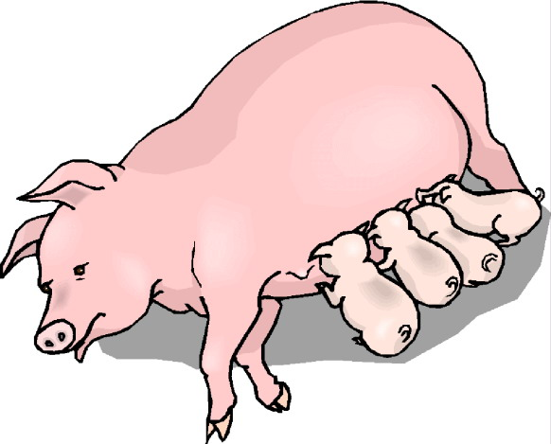pig | ______________________
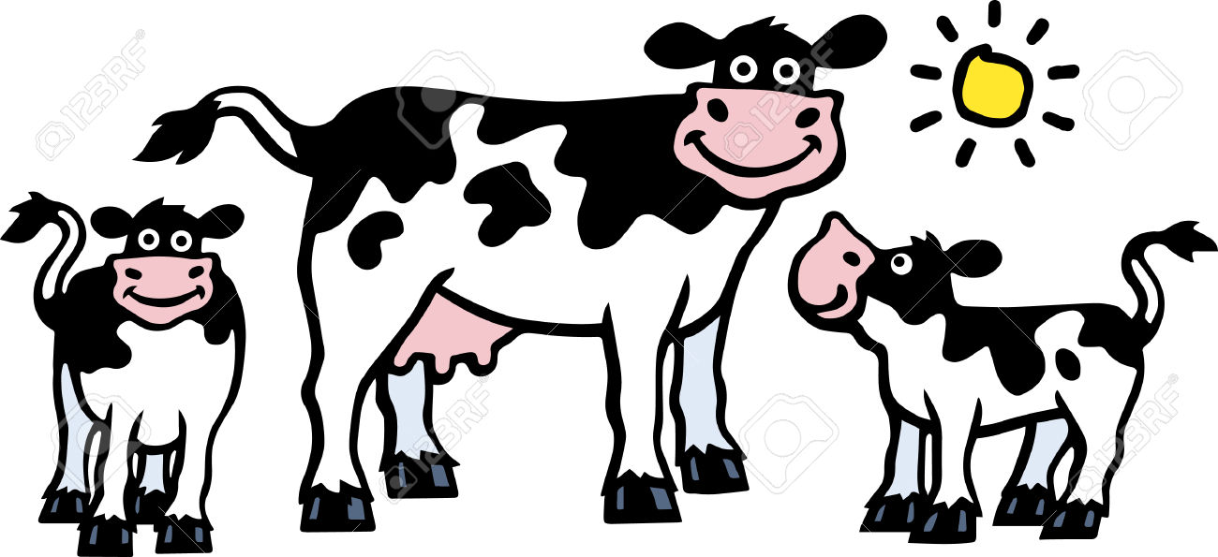cow | _______________________
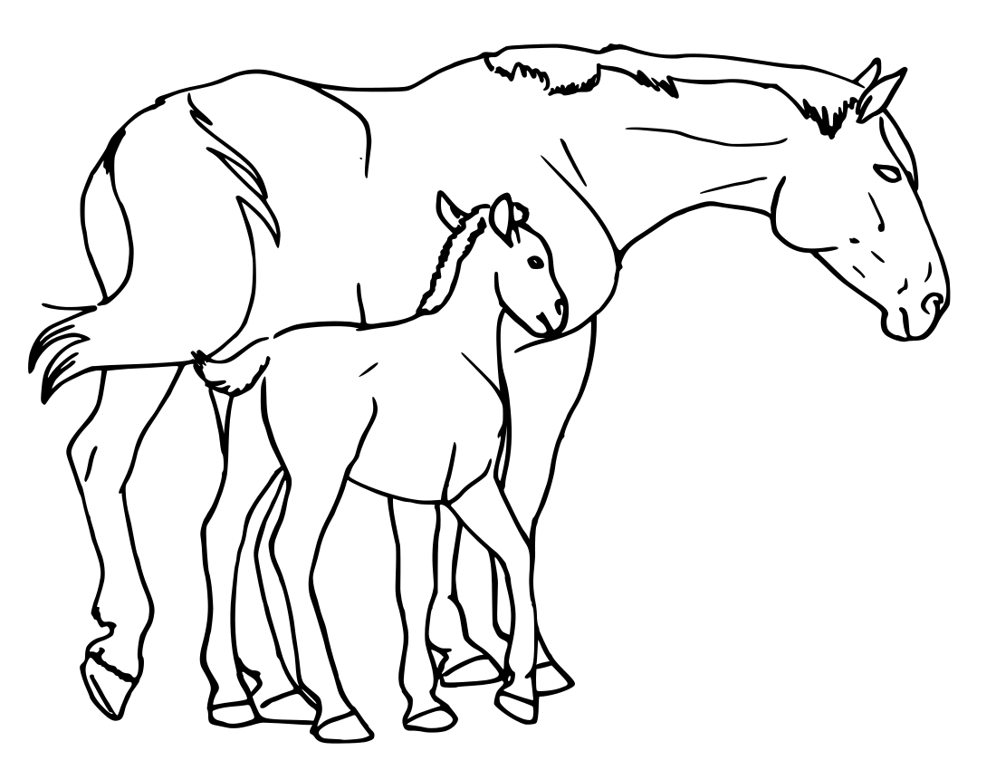horse | _______________________

4.3. | Rearrange the following words to form a good sentence.
 | many There animals zoo the at are  _________________________________________________________. | (2)
[10]

GRAND TOTAL: 40
GRADE: 4
ENGLISH FIRST ADDITIONAL LANGUAGE

TERM 2: EXEMPLAR TASK (Paper 2)
(RESPONSE TO TEXT & LANGUAGE)
MARKS: 40

MEMORANDUM

Marking Guideline/ Marking of Question 1 and 2
Comprehension and Visual text

- Spelling and grammar errors in longer answers are not penalised due to the fact that the focus is on comprehension
- Where one-word- answers are required and the candidate provides a full sentence, a mark should be allocated as long the correct word is highlighted or indicated in one way or the other.
- For open ended questions no marks are given for YES / NO / I AGREE / I DO NOT AGREE. The reason / motivation must be considered.
- For TRUE / FALSE or FACT / OPINION questions, marks are divided: 1 Mark for TRUE / FALSE or FACT / OPINION and a mark is given for the reason / motivation / quotation.
- Where two or three facts / points are required and the candidate gives a whole range, only the first two or three facts / points are marked.
- If the candidate uses words from a Language other than that from the question paper, the foreign words are ignored. If the answer (without the foreign words) makes sense, the candidate is not penalised. If the foreign word is required in the answer, it should be accepted.
- For multiple-choice questions BOTH the letter AND correct answer that is written out in full are accepted.
- As far as possible, lower- and middle order questions should precede
higher order questions.

Question 1: Informational text (15)

NO | EXPECTED ANSWERS | MARK ALLOCATION
1.1 | African √ | (1)
2 | 6350 kilograms / kg √ | (1)
1.3 | A or cool off √ | (1)
1.4 | An African elephant eats (any two responses – will be excepted) grass, small plants, bushes, fruit, vegetables, twigs, tree bark and roots. √√ | (2)
1.5 | Hard and rough (must have both descriptions to obtain the mark) √ | (1)
1.6 | Complete the following sentence:  Elephants use their tusks to (fight) and to (dig) √√ | (2)
1.7 | ivory √ | (1)
1.8 | They want (to get their tusks) √ so that they can (make jewelry and statutes.) √ | (2)
1.9 | B or scare √√ | (2)
1.10 | kill √√ | (2)
QUESTION 2: VISUAL TEXT (10)
2.1 | C or poster √√ | (2)
2.2 | Colchester Zoo √ | (1)
2.3 | You can meet the animals √ | (1)
 | You can take photos of the animals. √ | (1)
 | You can talk to their expert keepers. √ | (1)
2.4 | Any FOUR animals that are in the poster e.g. √√√√  Lion, giraffe, panda, bird, tiger, elephant, bear | (4)

[10]

QUESTION 3: SUMMARY (5)
Elephants never stop growing and they eat all day long.
They breathe and eat with their trunks.
They have big ears to help keep them cool and have two tusks, which are made of ivory.

SUMMARY RUBRIC
CRITERIA | POSSIBLE MARK | LEARNER MARK
Words filled in correctly in all 4 sentences. | 4
No punctuation & spelling mistakes | 1
TOTAL

QUESTION 4: Language Structures and Conventions in context (10)
Marking Guideline/ Marking of this section
- Spelling
  - One-word-answers are incorrect if the spelling is wrong
  - In full-sentence –answers wrong spelling is only penalized if the mistake in the language structure is assessed
  - Where an abbreviation is assessed,(if a punctuation mark is required ,it should be at the appropriate place).
- Sentence construction must be grammatically correct and must be presented in full sentences as indicated in the instruction
- Where direct and indirect speech and punctuation is assessed, half marks could be used.
- For multiple choice questions only the letter that corresponds with the correct answer

NO | POSSIBLE ANSWER | MARKS
4.1.1 | Elephants and trunks √√ | (2)
4.1.2 | big and long √√ | (2)
4.1.3 | their √ | (1)
4.2 | pigs √  Cows √ Horses √ | (3)
4.3 | There are many animals at the zoo. √√ | (2)
 | [10]

GRAND TOTAL: 40

